2020 Western Regional Noyce Conference
Portland Marriott Waterfront Downtown
February 21-23, 2020
Program

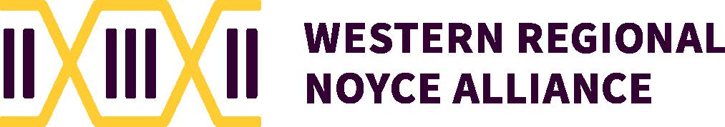

Portland Marriott Waterfront Downtown
Program-At-A-Glance
FRIDAY, 21 February 2020
4:00 - 5:30 | Registration
5:45-6:00 | Welcome – Opening Remarks | North Ballroom
6:00-7:00 | Keynote Speaker, Annette Lee | North Ballroom
7:00-8:30 | Reception, AAAS Noyce “Voices in the Field” Video Showcase | North Ballroom
SATURDAY, 22 February 2020
8:00 - 8:45 | Breakfast, Welcoming Remarks, AAAS Noyce “Voices in the Field” Video Showcase | North Ballroom
8:45 - 9:45 | Keynote Speaker, Beth Pratt-Sitaula | North Ballroom
9:45-10:00 | Break
10:00-11:15 | Parallel Sessions I
11:15-11:30 | Break
11:30-12:30 | Parallel Sessions II
12:30-1:45 | Lunch, Voices From the Field Panel, Donna Ross, Moderator. | North Ballroom
1:45-2:00 | Break | North Ballroom
2:00-3:00 | Parallel Sessions III
3:00-3:15 | Break
3:15-4:15 | Parallel Sessions IV
 | Dinner on your own
SUNDAY, 23 February 2020
8:00 - 8:45 | Breakfast, AAAS Noyce “Voices in the Field” Video Showcase  “Lightning Rounds” Scholars/Fellows Opportunities | North Ballroom
8:45 - 9:45 | Keynote Speaker, Oscar Leong | North Ballroom
9:45-10:00 | Break
10:00 – 11:00 | Parallel Sessions V
11:00-11:30 | Evaluation & Raffle Prizes, Sanlyn Buxner, University of Arizona  WRNC 2021, San Diego, Donna Ross, San Diego State University  Western Region Noyce Alliance, Lawrence Horvath, San Francisco State University  Closing Remarks, Stephanie Salomone, University of Portland

Keynote Speakers

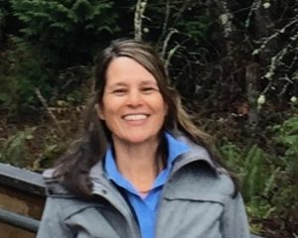  Annette S. Lee, Saint Cloud State University  From Native Skywatchers to ASTR 101 - Indigenous Perspectives of Astronomy and Relationship with Sky  Indigenous astronomical knowledge is rooted in the principle that ‘we come from the stars’. In D/Lakota, we are star people-Wicaŋḣpi Oyate and the stars are recognized as ‘our oldest living relatives’.  Dakota people are called Wicaŋḣpi Oyate, Star People. Our spirits come from the Creator down the Caŋku Wanaġi, the “spirit road,” more commonly known as the Milky Way. At death, we return where we came from along that same road. (Westerman and White 2012, 131)  Ojibwe refer to the North Star ‘Giiwedinanung’ or ‘The Going Home Star’ along with the saying ‘Everything you need is in the stars’. Ininew teachings include “we are Star People” and “All things made by Creator have achak (spirit)…This is why assiniuk (stones) are animate, not inanimate. …and this is how we are related to all things” (Buck 2018).  Native astronomies helped to make sense of life and relationships and reaffirm the belief in the interrelationship and interdependence of all things in an animate and living universe. Like the Earth, planets, and animals, celestial bodies are traditionally viewed by Native cultures as living beings with a creative life force that relates to and affects human beings physically and spiritually. (Cajete 2000, 216)  For tens of thousands of years, indigenous people have nurtured critical relationships with the stars, from keen observation and sustainable engineering to place-based ceremony, navigation, and celestial architecture. This talk will address: (1) what is interesting about the name of the state, “Minnesota”, (2) why relationship with earth and sky is relevant, and (3) how these ideas relate directly to STEM education.  *References on page 21 | North Ballroom
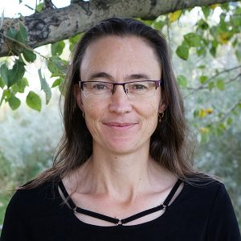  Beth Pratt-Sitaula, PhD, UNAVCO and Central Washington University  Science as a Springboard for Disaster Preparedness and STEM Literacy  Educators have a fantastic opportunity to situate STEM learning in the context of addressing societal challenges and thus motivate student learning while working towards greater resilience. For example, natural disasters are a captivating topic. Educators can capitalize on student interest in attention-riveting events such as earthquakes, tsunami, and volcanic eruptions, to engage them in the underlying science and learning related preparedness solutions. This talk will give examples from several successful professional development projects in the Pacific Northwest and Alaska that help educators gain the local science and preparedness knowledge to effectively motivate change in their schools and community while teaching really interesting STEM topics. Lessons learned from these programs can be applied to local issues in other locations by leveraging the appropriate STEM content alongside solutions for greater societal resilience.  Related websites:  Cascadia EarthScope Earthquake and Tsunami Education Program Alaska Native Geoscience Learning Experience  GEodesy Tools for Societal Issues | North Ballroom
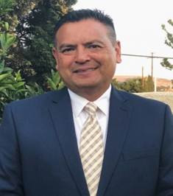  Oscar Leong, De La Salle North Catholic High School  Oscar Leong is the President of De La Salle North Catholic High School, which opened in 2001 to provide a faith-based, college preparatory high school education to underserved students from the Portland area. De La Salle was the first school to replicate the innovative corporate work study program pioneered by Cristo Rey Jesuit High School in Chicago. Students at De La Salle North Catholic High School attend class four days per week and work for a local company one day each week as part of the Corporate Work Study Program (CWSP). The CWSP provides work experience, business contacts, and helps offset the cost to educate them. This school exists to provide this unique educational opportunity to families who would not be able to afford a private, Catholic education. Their goal is to develop tomorrow’s community leaders by making high-quality education accessible to motivated young people in a learning environment that values cultural, spiritual, and ethnic diversity. Leong took over leadership of the school in 2018.  Leong came to DLSNC from Cathedral High School, a Lasallian Christian Brothers school in Los Angeles which serves more than 700 young men, primarily from low-income, Latino families. In addition to being a graduate of Cathedral, he worked at the school for 26 years in various roles, including English teacher and director of development and admissions. After attending the University of California, Berkeley where Leong majored in political science, he briefly entered the private sector before returning to his alma mater, where he worked until 2018. Leong is bilingual and has both Mexican and Chinese heritage. He and his wife of 25 years, Rosa, are proud parents of four children, the youngest of whom is a recent high school graduate. | North Ballroom

Parallel Sessions I, Saturday 10:00 - 11:15 (2 options)

Can you feel the Earth move under your feet? – GPS, Plate Tectonics, and Earthquakes  Beth Pratt-Sitaula | Salons F-I
A Session for Noyce Staff and Faculty  Kathleen Bergin | Salmon

Parallel Sessions II, Saturday 11:30 - 12:30 (6 options)

Teaching: The Best Kept Secret  Kristine Callan, Colorado School of Mines  Intended Audience: Noyce Project Leaders, Noyce Scholars and Teachers  If 45% of STEM majors nationally are interested in teaching, then why do we have a teacher shortage? One hypothesis is that potential teacher candidates are turned off by widespread misperceptions about the teaching profession. In this interactive workshop, participants will analyze data on the secondary teaching profession, and then compare these data with that of university instructors and industry workers. The goal is to ultimately improve teacher recruitment efforts. | Pearl
An Introduction to Noyce Project Evaluation  Sanlyn Buxner, Planetary Science Institute and Melissa Yisak, American Institutes for Research  Intended Audience: Noyce Project Leaders  The workshop will cover the basics of program evaluation for Noyce projects including needs assessments, formative assessments, and summative assessment. We will discuss the basics of building a logic model and different ways to collect and analyze data for project reporting. Lastly, we will discuss how to work with an external evaluator. | Eugene
Local and Relevant: How Phenomena Connect STEM with Students' Lives  Karin Lohwasser, University of California, Santa Barbara  Intended Audience: Science Teachers  Phenomena that are relevant to local communities, from the rescue of the island fox population to ocean acidification, will be introduced. We will discuss the roles such phenomena play in science and math classrooms: a) connecting STEM and students’ lives, b) strengthening students’ understanding of core STEM ideas, c) and anchoring units by linking these ideas through the real-world phenomenon. Small groups will then brainstorm and adapt ideas for their own context. | Columbia

Creating Consensus in Science Classes  Brian Foley, CSUN  Intended Audience: Science Teachers  NGSS instruction calls for students to create their own explanations of phenomena. But what should you do when your classroom has 30 different explanations of the same phenomena? Instead of having the teacher pick the winner, students need to engage in a process of reasoning and debate to come to consensus. We will talk about ways to scaffold consensus building so it can be done quickly and help everyone reach an accurate conclusion. | Salmon
Why Curiosity?  Jeri Janowski, Saturday Academy  Intended Audience: General Interest – All Participants  This hands-on workshop will teach teamwork to amplify curiosity in the classroom. This workshop is presented by Saturday Academy, an out-of-school STEM education nonprofit in Portland that provides classes, camps and high school internships to 6000 students annually in grades 2-12 (www.saturdayacademy.org). We will briefly review the neuroscience that underlies and why curiosity is important to learning. We will spend the rest of the workshop in hands-on demonstrations, many that can be taken back to your classrooms. | Meadowlark/  Douglas Fir
Identifying Core Values and the Development of Teacher Leaders  Ericka Lawton, Rice University  Intended Audience: General Audience – All Participants  This workshop is designed to help participants identify the core values that are used to guide choices as it relates to teacher-leadership and to find authentic ways of sharing them with others within the school community. Activities during the presentation will involve active learning strategies, group discussion and self-reflection. Participants will walk away understanding that leadership is not merely about their values. It is also about the values of those who interact with you. | Portland

Parallel Sessions III, Saturday 2:00 - 3:00(6 options)

Capture Them! Five Minute Engagement Activities to Use in Your STEM Classroom  Meghan DiBacco, University of Houston  Intended Audience: Math Teachers, Science Teachers, General  Participants will learn how to capture their student’s attention with quick five-minute engagement activities to promote student thought and questioning. This session provides examples of engagement activities and demonstrations pre-service and in-service teachers can utilize in their own classroom. Additionally, audience members will partake in these engagement activities and receive exemplary activities that were developed for middle school and high school classrooms. | Columbia
Helping Students to Overcome Math Anxiety  Mohamed ElHaga, University of Arizona  Intended Audience: Math Teachers  The goal of this session is to help high school math students reduce anxiety. Participants will engage by discussing presented information and data about student identified causes of anxiety and possible strategies for redressing math anxiety. Participants will become familiar with causes of anxiety in order to facilitate better learning environments and boost student enjoyment of math. | Pearl
Keeping the 'E' of STEAM in the Science Classroom  Nycole Marsh, University of Wyoming  Intended Audience: General Interest – All Participants  The team’s goal is to increase the engagement of engineering in science classrooms by highlighting five hands-on engineering projects that can be done in many STEM disciplines. Participants will gain an increase in self-efficacy and confidence that will ultimately lead to the overall improvement of engineering utilization in the curriculum. We will also help align this content to student goals, objectives, and standards that are applicable to a wide variety of students. | Portland

Recruiting and Retaining STEM Majors as Teachers  Leah McAllister-Shields, University of Houston  Intended Audience: Noyce Project Leaders  The purpose of this session is to share and discuss our recruiting strategies for a Noyce track 1 grant. We will share what we have learned throughout the past three years in an interactive and engaging format. Participants will learn about specific recruiting strategies that worked and did not work as a result of attending this session. Additionally, recruiting templates will be shared that can be modified for their own Noyce programs. | Meadowlark/  Douglas Fir
Breaking Barriers: Linguistics in STEM  Toresa-Goldy Ngalle-Mayer, University of Houston  Intended Audience: General Interest – All Participants  In the Breaking Barriers: Linguistics in STEM presentation, we aim to bridge the gap between academic vocabulary and where the student is. Participants will engage in student-centered scenario-based learning and will also be given a chance to formulate strategies for their own lessons. | Eugene
Integrating the Right Level of Inquiry in Your STEM Classroom  Selene Verhofstad, Rice University  Intended Audience: Noyce Project Leaders, General Interest  Participants will explore how any level of inquiry can transform STEM lessons. Preservice and in-service teachers will engage in guided, structured an open inquiry formats that can be effectively utilized with various student populations. Activities and discussions allow participants to analyze how varying levels of inquiry can be used to increase achievement and interest in STEM. Participants will leave with a better understanding of which level of inquiry works best in their classroom. | Salmon

Parallel Sessions IV, Saturday 3:15 - 4:15 (6 options)

Keeping it Real: Teacher-Led PLCs for Noyce Scholars  Cathy Davis, UCCS  Intended Audience: Noyce Project Leaders, General Interest  In this workshop we will provide an overview of an innovative Professional Learning Community model led by in-service STEM teachers from our partner LEAs. We will discuss the benefits of working together in tandem with these teachers. We will share and model a sample PLC activity and provide all attendees with a link to the Google Drive infrastructure that includes all of the PLC content from our Noyce program. | Meadowlark/  Douglas Fir
Infusing Culturally Responsive Pedagogy in STEM Classrooms  Paige Evans, University of Houston  Intended Audience: General Interest – All Participants  Research confirms that Culturally Responsive Pedagogy (CRP) is a vehicle for increasing student success in high need classrooms which broadens participation in STEM. teachHOUSTON, a secondary STEM teacher preparation program, has infused elements of CRP into their STEM education courses. This session includes interactive activities that will support teachers and faculty in their implementation of CRP into their STEM courses and/or programs as well as lessons learned during the first two years of implementation. | Columbia
Connecting Student Backgrounds and School Community Culture to Classrooms  Susan Holzknecht, University of Houston  Intended Audience: Math Teachers, Science Teachers  Participants will learn the importance of understanding student funds of knowledge (FOK) as a means to connect students and the school community to the classroom. A brief introduction to FOK will be followed by a self-inventory and small group discussions on classroom application. How to perform a cultural/community walk to uncover academic content in action will be shared. Participants will cooperatively work together to add FOK and community content connection ideas to a nationwide database. | Portland

Community Impacts of Near-Peer Observation at an Urban Commuter Institution  Janelle Johnson, Metropolitan State University of Denver  Intended Audience: Noyce Project Leaders, General Interest  Our goal for this session is to share our near-peer observation program designed to be beneficial for both current Noyce Scholars and alumni. We use the Ambitious Science Teaching (AST) observation tool to debrief the experience and discuss how to apply resources and strategies in the future—the session features extensive small and large group discussion. Session participants will learn and discuss the importance of near-peer opportunities and how these relationships prepare aspiring teachers. | Eugene
Becoming Leaders and Better Teachers Through Microcredential Development and Implementation  Armando Martinez Cruz, CSU Fullerton  Intended Audience: General Interest – All Participants  We will engage participants in activities selected to earn proficiency in two microcredentials (Cooperative Learning and Assigning Competence) developed by ATMALA teams. We will share the microcredential structure, the process of identifying specific instructional skills, and examples of criteria for proficiency. Our work is based on culturally responsive mathematics teaching and the first microcredential, Eliciting Students' Mathematical Thinking through Math Talk developed. We will share how this work impacts our own practice and students’ learning. | Salmon
Development of the Equity Literacy Observation Protocol for Secondary Teachers  Richard Orozco, University of Arizona  Intended Audience: General Interest – All Participants  The Equity Literacy Observation Protocol for Secondary Teachers (ELOPST) was developed to measure teachers’ equity literacy (EL) and ensure coherence between coursework, self-reported understandings of EL, and classroom practice. The goal of the presentation is to describe the process used to develop the ELOPST. I will engage the participants by providing the protocol for review and discussion. Participants will gain an understanding of EL and the importance and challenge of implementation. | Pearl

Parallel Sessions V, Sunday 10:00-11:00 (5 options)

Secondary Mathematics and Secondary Science Classroom Observation Rubric & Classroom Videos  Jaime Park, UCLA Teacher Education Program  Intended Audience: General Interest – All Participants  The goal of the presentation will be to introduce UCLA Teacher Education Program's Secondary Math and Secondary Science Classroom Observation Rubrics. Participants will watch classroom videos and use the rubric to understand best instructional practices that are student centered in math and science classrooms. Participants will also discuss how the rubric might be used to further learning through intentional feedback and reflection. The presenter will end with how UCLA Teacher Education Program uses the rubrics as frameworks for teaching and learning through intentional feedback, reflection, and evaluation. | Salmon
STEP UP Physics Together  Meghan DiBacco, University of Houston  Intended Audience: Science Teachers, Noyce Project Leaders  STEP UP is a national community of physics teachers, researchers, and professional societies. We design high school physics lessons to empower teachers, create cultural change, and inspire young women to pursue physics in college. Audience members will be introduced to the STEP UP program and engage in the introductory lesson. Additionally, participants will leave the session with exemplary lessons and resources to promote inclusivity in the classroom and inspire young women to pursue physics. | Eugene
Skipping Science: Identifying Factors Contributing to Non-participation in STEM Club  Heather Lentz, University of Arizona  Intended Audience: Science Teachers  Skipping science: Identifying factors contributing to non-participation in STEM club, explores the causes for the lack of participation among older students in an after-school STEM club. This action research project was conducted in a Title 1 school in rural Arizona. Results from this student voice project identifies the reasons for the lack of participation and potential changes needed to include these students. The participants will have an opportunity to offer suggestions, feedback, and share experiences regarding student participation in STEM clubs. | Pearl

Pacific Chemeketa Noyce Inspires Community College Program  Kevin Carr, Pacific University  Intended Audience: Noyce Project Leaders  How might community college partnerships empower Noyce institutions to further NSF's efforts to diversify the STEM teaching workforce? We will describe the work of "Pacific Chemeketa Noyce Inspires," a new Noyce program in which Chemeketa Community College students explore STEM teaching, participate in a STEM teaching internship, and transfer to complete a STEM degree and teaching license at Pacific University. We hope to share what we learn from this effort with the larger Noyce community. | Columbia
Fostering Learning Opportunities for All Students Through Formative Assessments  Carlos Perez, University of Houston  Intended Audience: General Interest – All Participants  Words associated with assessments have turned into daunting words for students and teachers. However, formative assessments can create and support a culture in which all students learn from mistakes. Participants will engage in a 5E lesson to explore: how students can learn from mistakes, misconceptions about formative assessments and some formative assessment ideas will be shared. Through this presentation, participants will be able to understand the impact of formative assessments in building students’ growth mindset. | Meadowlark/  Douglas Fir

Conference Organizers
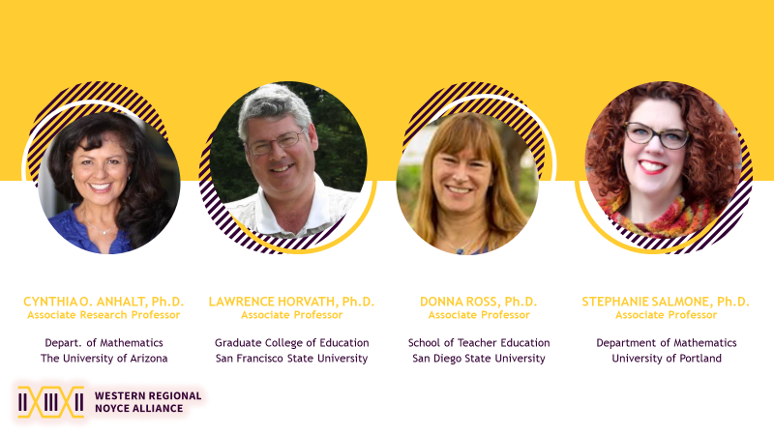

*References – Abstract for Annette S. Lee’s Keynote:
Cajete, Gregory A. 2000. Native Science: Natural Laws of Interdendence. Clear Light Publisher: Santa Fe, New Mexico.
Goodman, Ronald. 1992. Lakota Star Knowledge: Studies in Lakota Stellar Theology. Sinte Gleska University.
Lee, Annette S., and Jim Rock. 2015. “Native Skywatchers and the Makoce Wicaŋhpi Wowapi— D(L)Akota Star Map—Building Community Around Native Star Knowledge,” 15.
Lee, Annette S., Jim Rock, and Charlene O’Rourke. 2014. Dakota/Lakota Star Map Constellation Guide: An Introduction to D/Lakota Star Knowledge. Minnesota: Native Skywatchers Press.
Lee, Annette S., Jim Rock, William Wilson, and Carl Gawboy. 2012. “Red Day Star, the Women’s Star and Venus: D (L/N)akota, Ojibwe and Other Indigenous Star Knowledge.” Science in Society, 153.
Simonelli, Richard. 1994. Sustainable Science: A Look at Science Through Historic Eyes and: Through Eyes of Indigenous Peoples. Bulletin of Science, Technology & Society. US: STS Press.
Westerman, Gwen, and Bruce White. 2012. Mni Sota Makoce: The Land of the Dakota. Minnesota Historical Society Press.

