LED MIRROR
Requirements and Functional Specifications
EE 483 – Senior Design

Team Members:
Nathan Lee
Jim Rowe
Dalton Faker
Kian Sadjadi

Faculty Advisor:
Dr. Peter Osterberg

Industry Advisor:
Matt Clark
Project Customer:
University of Portland: Shiley School of Engineering

University of Portland
Shiley School of Engineering

REVISION HISTORY
Version | Author | Date | Reason for Change
0.1 | Team | 9/20/2019 | N/A
0.9 | Kian Sadjadi | 9/23/2019 | Assigned for one voice
0.95 | Kian Sadjadi | 9/27/2019 | N/A
1.0 | Kian Sadjadi | 10/11/2019 | N/A
Table 1- Revision History

Contents
REVISION HISTORY................................................................................................................. 2
LIST OF FIGURES..................................................................................................................... 3
LIST OF TABLES...................................................................................................................... 3
INTRODUCTION......................................................................................................................4
REQUIREMENTS.....................................................................................................................4
Overview........................................................................................................................ 5
General Specifications.....................................................................................................6
Technical Specifications...................................................................................................7
PRIMARY USE........................................................................................................................7
Entertainment................................................................................................................7
Saftey & Secutrity.................................................................................................................7
Educational Aid.............................................................................................................7
USER INTERFACE..................................................................................................................7
DEVELOPMENT PROCESS........................................................................................................7
MILESTONES.......................................................................................................................9
Functional Specification Document (Ver 0.9, 0.95, 1.0)....................................................9
Final Budget..................................................................................................................9
Design Document (Ver 0.9, 0.95, 1.0).............................................................................9
Website Finalized with Fall Documents...........................................................................10
Hardware Test..............................................................................................................10
Complete Prototype......................................................................................................10
Founder’s Day Presentation...........................................................................................10
Website Finalized with Spring Documents......................................................................10
BUDGET.............................................................................................................................10
FACILITIES...........................................................................................................................11
TECHNICIAN ASSISTANCE........................................................................................................11
RISKS.................................................................................................................................11
Removal of Team Member............................................................................................11
Falling Behind Schedule.................................................................................................11
Damaged Components..................................................................................................11
Assembly Issues............................................................................................................11
CONSTRAINTS......................................................................................................................11
Technical......................................................................................................................11
Economical...................................................................................................................12
Environmental..............................................................................................................12
Health and Safety..........................................................................................................12
Manufacturability.........................................................................................................12
Professional………..........................................................................................................12
Ethical & Legal…….........................................................................................................12
Security……………...........................................................................................................12
Sustainability……….........................................................................................................12
Codes & Standards.........................................................................................................12
Social & Political…..........................................................................................................12
CONCLUSION.......................................................................................................................12
GLOSSARY..........................................................................................................................13
BIBLIOGRAPHY.....................................................................................................................13
APPENDIX A........................................................................................................................13

LIST OF FIGURES
Figure 1: LED Mirror Example.........................................................................................................4

Figure 2: LED Mirror Block Diagram................................................................................................5

LIST OF TABLES

Table 1: Revision History.........................................................................................................2

Table 2: Milestones.................................................................................................................9

Table 3: Budget.....................................................................................................................10

INTRODUCTION
The LED Mirror project is a creative take on a mirror utilizing modern and artistic elements. This idea was inspired by the Lots of LEDs project (a previous electrical engineering capstone project from 2012) with a plan to advance the display characteristics and add a user input. This project includes an LED/sensor array, Arduino, and FPGA which allow the display to be interactive with its environment. The LEDs will also change color according to distance. Our team was driven to take up this project as we wanted to create a memorable display that would inspire future teams as the previous capstone project inspired us. Figure 1 is a fully fleshed out example of an LED Mirror. The sensors sensing the person’s body and corresponding LEDs lighting up to create a mirror image of that person made from light. Through taking on this project, our team intends to demonstrate our engineering, design, and project management skills in order to prepare ourselves for working in industry. The following document will summarize the functional specifications such as milestones, progress, and other relevant data that describes our project.
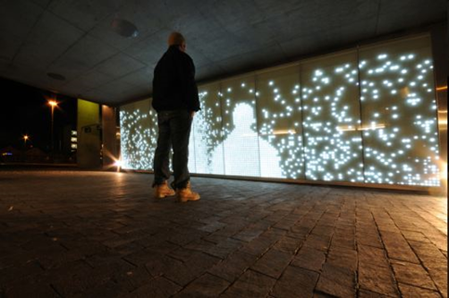
Figure 1: LED Mirror Example

REQUIREMENTS

Overview
The LED Mirror contains a logic controller, one Arduino, and a 500 LED array with motion sensors. The figure 2 below demonstrates how the components will interact with each other. Each block is labeled to describe its function in the project and each net to describe what will be transferred along it to the next block.
The logic controller is what will manipulate and control the digital signal coming in and displaying the signal properly on the LED array. It will control the addressing of the array to allow the image to be updated without remembering each LEDs value. The controller is the user interface, buttons and switches will determine what type of manipulation will be done to the signal. This is the main FSM (Finite State Machine) and there are no sub FSMs that it controls. The controller will still be modularized, but all branch and state logic are done centrally.
The Arduino is the link between the LED sensors and the logic controller. It will convert the analog signal from the sensors to digital, to allow the logic controller to process the sensors output. Due to the number of pins from 500 LEDs, an addressing system has been devised to reduce the number. The pins of the Arduino can be found in Appendix A.
SPI (a simple 4-bit signal) that is used to communicate hardware, will be sent from the Arduino to the FPGA. This signal is the unrefined digital signal that will be sent to one of the LEDs in the array. SPI is difficult because it would require a certain protocol to be followed on both ends of the transfer.
The sensors will be attached to each array but not directly to the LED itself. Each Sensor has a LED it controls and due to addressing by the logic controller the signal from the sensor can be displayed on the proper LED without being connected directly.
The LED array will take digital serial line and based on the address the logic controller outputs, that signal is sent to a LED to change its color based on the Sensor at that address and the manipulation the controller performed.
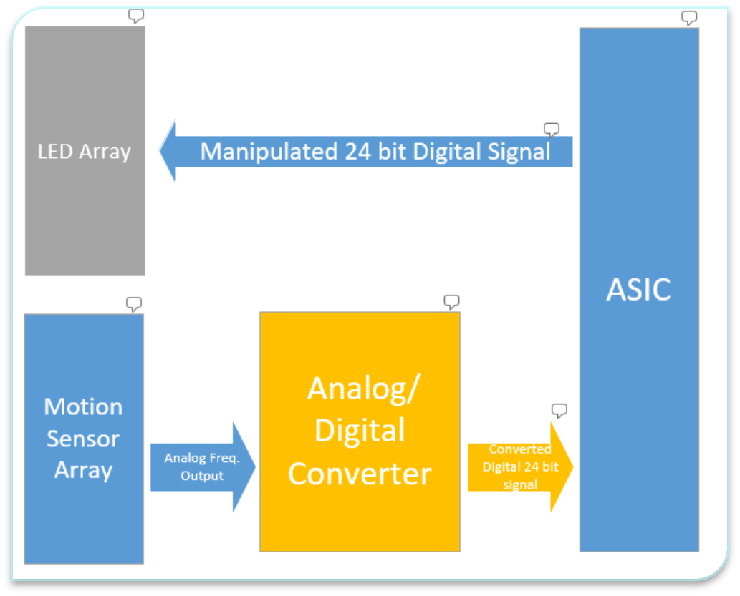
Figure 2: LED Mirror Block Diagram

General Specifications
Size – The display will be at maximum 5 x 5 feet tall consisting of 500 multi-color LEDs. It will be at minimum 1 x 1 feet tall and consisting of 100 multi-color LEDs On the same scale there will be 500 UV-Sensors with minimal spacing between sensor and LED’s. Behind this display there will be space for an Arduino board for interfacing, an FPGA for the display logic and all the interconnect cables. Buttons and appropriate user interface must also fit on this device.
Shape – The device will be a vertical wall display of LED’s with a small box on the back for the logic components. Each side of the board will have stabilizers, so the wall will not easily be knocked down.
Weight – The weight is not extremely important as the display is meant to be completely stationary and more of an installment than mobile fixture. It should be heavy enough not to be knocked over easily.
Operating Conditions -- the device must be operated indoors and at room temperature; it will be susceptible to water damage due to minimal direct contact (such as rain or anything more) due to electronic components and wiring which will not be watertight. It will work in temperatures ranging from 0 degrees to 100 degrees.
User Safety – The device will be safe to interact with and therefore must be electrically neutral. This will prevent any accidental electrical shocks to users. The wall will be made from insulating material and all electrical components will be safely housed inside.

Technical Specifications
Power Supply – This project will be powered by a standard 110VAC driven +5V, 10A brick DC power supply capable of driving LED bank, Sensor bank, an Arduino board and a standard FPGA.
Clock Signal – As all the components are digital, networking between all them will need to be controlled by a master clock. The clock will be determined by the FPGA as it will control the logic to the whole system and the 5V frequency.
Required Hardware – The logic for the display will all be done on the FPGA while the output from the sensors will be decoded and manipulated on the Arduino board. The LED’s and sensors will be interacting with these components through a series of busses.

PRIMARY USE

Entertainment

The primary goal of this project is to make an LED display to mirror shapes in front of it. We wanted to create a display which is pleasing to the eye and a semi-permanent addition to Shiley school.

Environmental

If this were to be implemented on a larger scale it could be used in public walkways as environmentally-friendly lighting. The lights would only turn on if there were someone present.

Educational Aid

The project can be used as an educational aid for undergraduate students. We used skills such as programing for Arduino, digital design for the display's logic as well as real-time digital processing in networking between components. These are important skills for those who want to pursue most careers in electrical engineering.

USER INTERFACE
The user interface is split into two parts. The first interface is the user who the LED Mirror is sensing. The user will walk in front of the array where the sensors will track their movement and display the user on the LED array. Once the user is out of range of the sensors the LED Mirror can no longer track them. The second interface is that the user can specify what type of image they want to display, using the specified buttons connect to the logic controller. Options are strobe, distance-based color, rainbow, shadow etc. These two parts are designed to be user friendly

DEVELOPMENT PROCESS

Project Proposal and Charter
This project was proposed by Nathan Lee, Kian Sadjadi, and Jim Rowe to Dr. Osterberg during the Spring semester of 2019. The project was approved and Dr. Mansouri was set to be our faculty advisor. However, over the summer, our advisor changed to Dr. Osterberg and Dalton Faker was added to the team as a fourth member. Our team had to reassign roles and each person was given a part that worked to their individual strengths. Each team member ‘s role was kept on a charter created to keep responsibility between all 4 members.

Functional Spec Document
Our team will write a Functional Specifications Document that will describe the process of, and how the LED Mirror Project will operate. The document includes the how project was made, how it works, all related diagrams, constraints, milestones, risks, and all requirements related to the development of the project. The overall goal of the Functional Spec Document is to be a guide during the process of designing the LED Mirror.

High Level Block Diagram
The project utilizes the interaction between major components such as the FPGA logic controller, Arduino programing platform, and LED matrices. Once a final design is determined, each team-member will work on a specific part of the project assigned to them.

LED Logic Controller Design
The LED logic controller will be designed and coded from an Arduino board through an ASIC to control the LED’s and sensors through the use of a manipulated 24-bit digital signal.
LED Logic Controller Test and Debug
The LED logic controller must be designed using the Arduino and ASIC and will be simulated with testbenches that check the reaction between all the components. If the testbenches succeed, then the group will be able to go onto physical testing a proof of concept. Each component will be tested through each part, meaning the first part must work before the next can be worked on.

Program Arduino to Interact with Controller
The Arduino will be programmed to interact with the LED controller constantly updating the sensors to turn the lights on or off depending in what the sensor picks up and sends to the Arduino.

Design FPGA to Control LEDs
The FPGA will be coded through an ASIC and control the LEDs based on the sensors and respond with the appropriate signals.

Design Document

The design document will present the final specifics of the project design including the FSM’s, code functionality, and ASIC Design.

Design Device Case

The device case will be designed with wood and made at the University of Portland with the help of technicians.

Physical Testing and Debugging
A proof of concept will be used to test the connection between the ASIC, Arduino, and LED array. The device will also be physically tested to make sure every LED sensor works.

Founder’s Day Presentation
The final project will be presented and demonstrated during Founder’s Day to advisors, faculty members, students and guests.

Final Report
The final report will contain the entire project and everything that was accomplished.

MILESTONES
Milestones | Completion Date
Functional Specification Document (ver 0.9) | September 19, 2019
Website Up and Running | September 24, 2019
Functional Specification Document, (ver 0.95) | September 27, 2019
Functional Specification Document, (ver 1.0) | October 11, 2019
Final Budget | October 11, 2019
Preliminary design completed | October 11, 2019
Design Document (ver 0.9) | November 1, 2019
Design Document (ver 0.95) | November 8, 2019
Design Document (ver 1.0) | November 29, 2019
Peer Evaluations | November 29, 2019
Website Finalized with Fall Documents | December 1, 2019 (tentative)
Shiley Winter Showcase (Poster) | December 6, 2019
Hardware Test | March 6, 2020 (tentative)
Completed Prototype | March 20, 2020 (tentative)
Website Finalized with Spring Documents | April 1, 2020
Founder’s Day Presentation | April 10, 2020
Table 2 - Milestones

Functional Specification Document (Ver 0.9, 0.95, 1.0)
The functional specification document provides an overview of the operation and scope of the project. The document will be updated with more detail as more milestones are reached. Version 1.0 will be the final revision prepared for submission.

Final Budget
The final budget is a bill of materials alongside associated pricing data. It will contain all parts necessary to create the project and necessary spare parts.

Design Document (Ver 0.9, 0.95, 1.0)
The design document provides a detailed look at how the product described in the functional specification document will be realized. This includes the overall plan, block diagrams, networking diagrams, final design device specifications, and logic diagrams. Version 1.0 will be the final revision prepared for submission.

Website Finalized with Fall Documents
The website will be intermittently updated throughout the course of the project. It will be kept up-to-date with milestones, breakthroughs, and additional information.

Hardware Test
The project utilizes many wires and components. Each component must be tested prior to fabrication to minimize faults in the final fabrication. This will make functional testing easier once the prototype is completed.

Complete Prototype
Once hardware is tested the prototype must be fabricated. This includes soldering and wiring numerous LEDs and Sensors. Each component of the prototype will be tested to ensure full functionality.

Founder’s Day Presentation

We will present our project in front of industry advisors, faculty, our colleagues, and guests. Our presentation will describe our project, describe our design process, and demonstrate our prototype.

Website Finalized with Spring Documents
All project documentation will be uploaded to our website.

BUDGET
Item | Quantity | Cost per Unit | Total Cost
LED’s | 500 | $1.00 | $500.00
Sensors | 500 | $2.00 | $500.00
Arduino | 2 | $30.00 | $60.00
Plywood | 5x5 plywood, base | $15.00 | $15.00
Wires | 15 bundles | $15.00 | $45.00
Power Supply/Brick | 1 | $30.00 | $30.00
Shipping | $50.00 | $50.00 | $50.00
TOTAL |  |  | $1650.00
Table 3 - Budget

FACILITIES
The main facility that will be used to assemble and test components will be the Shiley 306 senior design lab. All components can be put together in the 306 lab, no other maker space is needed.

TECHNICIAN ASSISTANCE
The technician Jared Rees will assist the team in putting together the design box that will contain the LED array and Arduino. He will also help clean, route wires, and connect the components. Assistance will also be needed to solder the LED to the wires.
RISKS

Removal of Team Member
If a member is removed from the team their tasks will be split among the remaining team members. Given that the team was assigned to a team of three, this occurrence should have little impact on the outcome of the project. If the resulting workload is too intense, certain features may be removed from the design.
Falling Behind Schedule
Falling behind schedule will be a serious problem should it occur. This project requires a significant amount of fabrication. As such the design should be completed by Thanksgiving. Should a team member finish their tasks earlier, they may be assigned to assist other team members with their tasks. If the team is far behind schedule, certain features may be removed from the design.

Damaged Components
The risk of having malfunctioning components is low. As we have many parts, components will be tested prior to fabrication to minimize the risk of malfunction. Extra components will be ordered to replace any malfunctioning parts.

Assembly Issues
The chance of having assembly issues is relatively high. This project contains a large amount of fabrication. To minimize the possibility of error, we will carefully plan before beginning the manufacturing process. We will consult Jared Rees, to find the most effective way to fabricate our prototype.

CONSTRAINTS

Technical
Networking Interface: due to the number of pins and how some of the components receive data, a networking interface such as the SPI, might be needed. These interfaces require a protocol to be followed accurately and without fail to receive and transfer data
Addressing: Also, due to the number of pins we cannot simply hardwire every pin to the Arduino and the FPGA. So we must devise a plan to address sensors and LEDs to reduce the number of pins in the Arduino and FPGA by a factor of 2 to the power of n.
Sensor: The sensors we have looked at are not accurate and precise enough to pick up an image as small as a hand or too wide of range that sensors will overlap. The preliminary sensors have a range of 5 feet, meaning that it would affect the spacing between the LEDs and the sensors.

Economical
Sensors: they will be the most expensive part of this project. They are twice as much as the LEDs. Because of this, the higher end the sensor, the more expensive it will be.

Environmental
Sensing: where the project is set up can affect how well the sensors can sense objects. Also, some people may not like to be tracked and will complain about the placement of the project.

Health and Safety

People prone to epilepsy could experience a problem due to the number of flashing lights.

Manufacturability
The project will require a high number of LEDs and sensors. There is a possibility that they could be delayed because of a manufacturing shortage from the supplier.

Professional

Does not apply.

Ethical & Legal

Does not apply

Security

Does not apply

Sustainability

LEDs wear out overtime, so within the next 4 or 5 years, the lights might degrade and will need to be replaced. We plan to overcome this by designing it so the LEDs and sensors could easily be replaced

Codes & Standards

The Codes and standards that will need to be upheld are safety standards of the project being built correctly, being grounded to be used correctly.

Social & Political

Does not apply.

CONCLUSION
In conclusion, this project involves research, design, building and testing of an LED mirror. This version is more complex than similar projects from which we were inspired. Our team must utilize our creativity to improve upon the functionality of previous projects and use the technical skills we have learned over the course of our college experience to realize our vision. The key components in our design will be the networking between sensors and LEDs and the controller, which will be an ASIC designed in a simulation board. We expect the prototype to be used for artistic and educational purposes.

GLOSSARY
FSM - Finite State Machine
FPGA - A Field Programmable Gate Array can be used to simulate hardware designs.
Arduino - An inexpensive single board computer (micro-controller) which can be programmed and has I/O pins allowing for easy interaction with other electronics.
LED - A light source that is created by a light emitting diode.
SPI - A simple 4-bit signal that is used for communication between hardware.

BIBLIOGRAPHY

PinMapping168. (n.d.). Retrieved from https://www.arduino.cc/en/Hacking/PinMapping168

APPENDIX A
The diagram below is a pin diagram of the Arduino board that will be utilized for the project:

