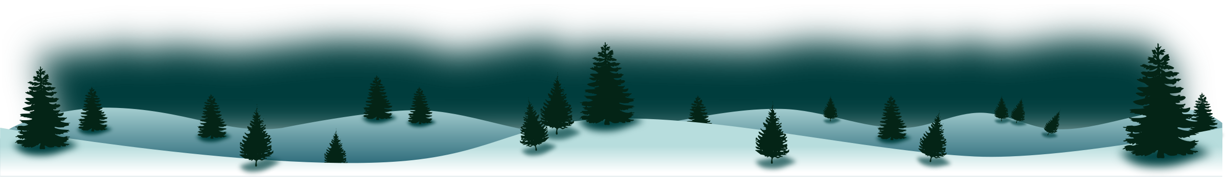
Wintertime Rebus Story
Directions: A rebus is a story that combines words and pictures. Use the document below to write a winter-themed story, using emojis to replace common winter words in your story.

Here are some sample emojis you can copy and paste:
🎄🌲🎅🤶🎿🏂⛄🎀🎁🎉🐁👪👦👧👨👩👴👵👶👼💤🛌❄❅❆🕎🚗🍴🍗🥛🍪⏰🌅

Or you can add different emojis by clicking "Insert" then "Special characters" then "Emoji".

