Doctoral: IRB Package Checklist

1. IRB application completed (no unanswered questions) | ☐Yes | ☐No
2. Informed consent - Correct GCU Informed consent template  - Click here to access the latest version of CDS templates. | ☐Yes | ☐No
3. Informed consent- Signature line intact if confidential study | ☐Yes | ☐No
4. Informed consent- Agree and Disagree buttons intact if anonymous study | ☐Yes | ☐No
5. Correct GCU Recruitment template (screening criteria is embedded in the inclusion criteria).  - Click here to access the latest version of CDS templates. | ☐Yes | ☐No
6. Inclusion, Exclusion and Activities must match exactly across the IRB application, informed consent and the recruitment. | ☐Yes | ☐No
7. Readability report for informed consent attached and rates Flesch Kincaid of 9.0 or less | ☐Yes | ☐No
8. Readability report for recruitment attached and rates Flesch Kincaid of 9.0 or less | ☐Yes | ☐No
9. If online survey or questionnaire, include direct live link in the Recruitment letter. …more details below | ☐Yes | ☐No
10. Exact first and separate page of the live link is the approved GCU informed consent. Once accepted or signed, participants should enter the demographics (if used) and then enter the survey/questionnaire. | ☐Yes | ☐No
11. Is the site authorization or permission to use instruments outdated? (Good for one year from date of approval) …more details below | ☐Yes | ☐No
Created by Dr. Twyla Williams-Damond, SDA Lead-IRB/ IRB Supervisor

Additional Details for checklist items are provided within this document below.

Additional Information

What is the best way to access the most up to date version of a GCU template?
To be sure that you and your learners are accessing the most up to date version of the GCU template, navigate to the forms and templates folder in the DC Network.
Click here to access the folder in the DC Network.

How to review the GCU Application and Submission Packet.
To review the application, follow the steps outlined in the instructional document posted in the DC Network. Click here to access the document in the DC Network.

7. and 8. Readability Reports
When a learner is prompted to upload a readability report, they are provided instructions on how to complete this process. An example of this question is posted here. When you review a readability document, please ensure that they followed the instructions below.
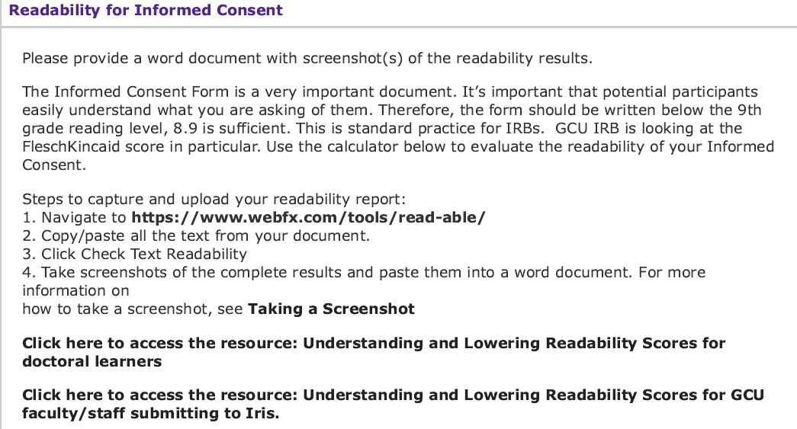

9. If online survey or questionnaire, include direct live link in the Recruitment letter and in the applicable application question.
While you review the application, check to ensure that the learner included the direct live link in the following question “Is your survey online?”
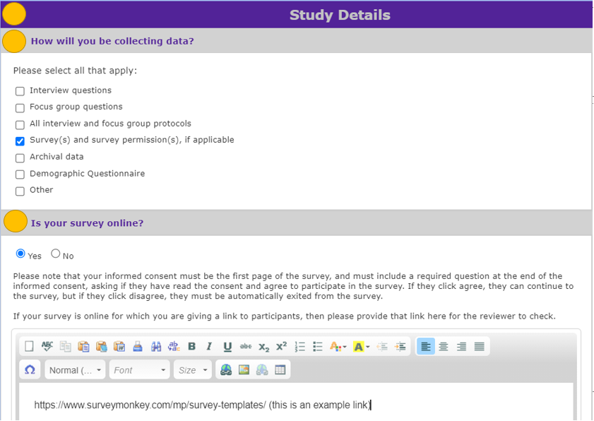

11. Is the site authorization or permission to use instruments outdated? (Good for one year from date of approval. A clear date and time stamp should be visible.)
To confirm, review the application question within the Recruitment section. The learner is asked to list all site where they will recruit and provide a date the site authorization was received. Approval is good for one year from the date of approval.
